Dear ,
I am not in the habit of writing to my parliamentary representative as I believe in representative selection and trust that our democracy should work. However believe that something is seriously amiss in our government.
I find myself appalled and disappointed that the people who are entrusted to guide a nation - and who have historically sought to set an example to the developing world - could possibly advocate such an abhorrent policy. It will not work as a smokescreen to the earlier issue of the Prime Minister and Chancellor being fined for illegal activity during lockdown, and it is equally unacceptable that such inhumanity is being touted as being reasonable and rational. Furthermore, to release this at the point of one of the most significant religious festivals strikes me as being particularly inappropriate.
The Presidency of the Methodist Church have released the following prayer and statement following the Prime Minister’s announcement.
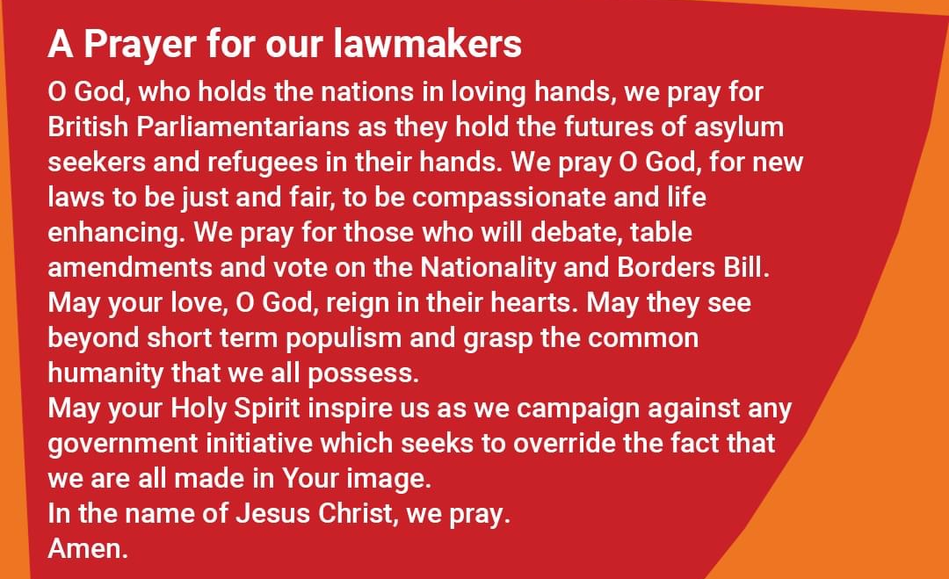
"The Government’s plans to offshore asylum seekers in Rwanda gives yet another insight into its hostile, uncompassionate and ineffective response to asylum seekers and refugees."
Read the full statement here: http://ow.ly/puPk50IJU2L
I implore you to stand against this outrageous proposal and to call for the entire scheme to be abolished.
I look forward to hearing from you about this. I would hope to have at least an acknowledgment of receipt by the start of next week.
Yours faithfully,

